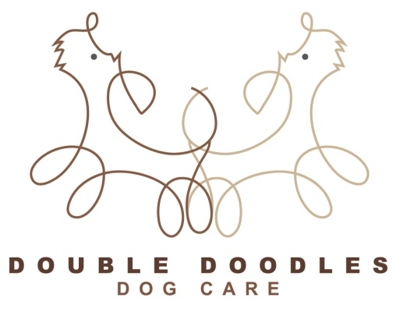
Day Care
TERMS AND CONDITIONS (please read and sign)
I (the owner) confirm to Double Doodles that I am the legal owner of my dog; that my dog has not been ill with any contagious disease or condition within the past 30 days and that my dog has received all necessary vaccinations.
I also confirm that my dog has not harmed or shown aggression or threatening behaviour toward any person or any other dog.
I understand that Double Doodles is an open, free running day care centre and I agree that my dog will socialise with other dogs and I accept the risks involved and agree that Double Doodles are not liable for any injuries or illnesses resulting during my dog’s attendance. I am responsible for the payment of any medical treatment that my dog may receive while at Double Doodles and I agree to pay all vet’s care and costs that may arise as a result of illness or injury
I confirm that I will supply proof (and copies retained) for the following canine vaccinations – Canine Distemper, Canine Hepatitis, Canine Parvovirus, Leptospirosis and Kennel Cough. I also understand that even in a safe and clean environment that my dog could still contract Kennel Cough. I agree I will not hold Double Doodles responsible if this occurs
If any medical problems develop while my dog is in the care of Double Doodles and I cannot be contacted, I authorise them to do whatever they deem necessary for the safety, health and wellbeing of my dog and I agree to assume full financial responsibility for full financial responsibility for all expenses incurred
I understand that the external fences (6ft) are as safe as is reasonably practical and accept that should my dog escape I am liable for any damage and injury caused.
I understand that The Control of Dogs Act 1992 stipulates that all dogs in a public place must wear an identity tag and collar. We recommend a quick release collars for safety reasons
I agree that I must pay for day care on collection of my dog. Further charges will be applicable for early drop off and late collections
I agree to my dog being photographed, videotaped and used in any media or advertising by Double Doodles
ACCEPTANCE OF TERMS AND CONDITIONS
I have read all of the above and agree.
SIGNED PRINT NAME DATE

