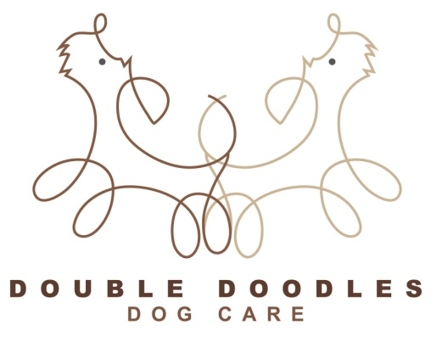
Dog Grooming Consent and Release Form
Emergencies
In the event of an emergency, I authorise Double Doodles to immediately seek a vet’s attention for my dog, at my expense. I understand that all attempts will be made to contact me in the event of an emergency.
Coat Condition
I understand that Double Doodles puts my dog’s comfort above all else. In the event that my dog’s coat is matted, I understand that the groomer may have to shave matts out rather than perform a painful de-matting procedure. I also understand that if my dog is severely matted, that there is an increased risk for clipper burn or cuts to occur. I understand that all attempts will be made to prevent this, however in many extreme matt conditions, it is unavoidable. I also understand that matted dogs take additional time to groom so there will be an additional fee added on the regular price if my dog’s coat is matted and requires extra care
Health
I understand that grooming can be stressful to some pets and I will inform the groomer if my dog has any heart conditions or any stress related issues prior to grooming
Cancellation policy
I understand if I have to change my appointment time or cancel it, that I must give at least 24 hour notice so that the appointment time can be made available to another client who is on the waiting list. If two appointments are missed without giving notice, you will be expected to pre pay prior to scheduling any future appointments
I have read and understood the above policies

SIGNATURE DATE

NAME DOG’S NAME

